**Alert Watch and Response Engine (AWARE)**

VistA/CPRS Alert Processing Guide



August 2015

Prepared by Harris Corporation

Revision History

| Creation Date | Version No. | Description/Comments | Author(s) | Reviewer(s) | Review Type | Issue Date |
| --- | --- | --- | --- | --- | --- | --- |
| 7/28/2015 | 0.01 | Initial version | S. Greenacre | G. Welch |  |  |
|  |  |  |  |  |  |  |
|  |  |  |  |  |  |  |

Table of Contents

1 Purpose 2

2 Project Description 2

3 AWARE Functionality 2

4 Configuration Requirements for User Setup 2

5 AWARE VISTA/CPRS ALERT PROCESSING 3

5.1 Creating AWARE Alerts for Critical Labs Alert Categories 3

5.2 Creating AWARE Alerts for Abnormal Imaging Alert Categories 14

6 Processing AWARE Prompts/Pop-Ups 23

List of Figures

Figure 1 - Selecting Location for Current Activities 4

Figure 2 - Order a Lab Test 5

Figure 3 - Click the Quit Button 6

Figure 4 - Review/Sign Changes 7

Figure 5 - Lab Test Number 8

Figure 6 – Reflections VistA Logon 9

Figure 7 – Refresh Patient Lab Test Data 12

Figure 8 – Patients Lab Test Data 13

Figure 9 - AWARE Prompt 14

Figure 10 – Enter Imaging Order 15

Figure 11 –Order Checking 15

Figure 12 – Sign Imaging Order 16

Figure 13 – Order Check 16

Figure 14 – E-Sign Order 17

Figure 15 – Reflections VistA Logon 18

Figure 16 – Close Chart & AWARE Prompt 23

Figure 17 –AWARE Follow-Up Action Tracker Prompt 24

Figure 18 –AWARE Follow-Up Progress Note 24

Figure 19 –AWARE Reminder Dialog 25

Figure 20 –Alert Viewer Status Tab 26

Figure 21 –AWARE CPRS Patient Selection 27

Figure 22 –Alert Viewer Patient Detail – Status Tab 28

# Purpose

The purpose of this document is to provide a guidebook of instructions on how to create and process AWARE Alerts using AWARE CPRS and VistA functionality. It starts following an AWARE software KIDS build for AWARE Alert types including associated Reminder Dialogs.

# Project Description

The Computerized Patient Record System (CPRS) View Alerts package delivers notification of non-life threatening critical test results; however, it does not track whether providers take appropriate follow-up actions in response to the alerts. Currently, the only way to track follow-up actions on critical alerts is through manual review of individual patient records. The innovation Alerts, Watch and Response Engine (AWARE) will track and monitor follow-up actions and will identify certain critical lab and imaging test result alerts that lack timely follow-up. AWARE consists of an AWARE CPRS program with underlying dll, an AWARE Alert Tracker program, web-based Knowledge Base (KB) editor, an Alert Viewer, and QI Reporting Tool.

# AWARE Functionality

AWARE uses CPRS View Alerts package along with the Alert types defined from the AWARE KB Editor to track these Alert type. An AWARE process in TASKMAN uses data configured and stored by the AWARE Knowledge Base Editor to look for matching Alert information in the CPRS Alerts package found in the ALERT TRACKING File. If a match is found an AWARE Alert is created and tracked in a VistA Alert Cache file.

# Once the Alert is created in the Alert Cache file, it is tracked for specific Follow-Up actions done by the ordering provider, or other team member. A valid Follow-up Action can occur when the Alerting patient’s provider enters a lab or medication order with orderable item, consult, or procedure that matches one of the items configured in the elements of a Reminder Dialog defined for an Alert type file with the AWARE KB Editor. A valid Follow-up Action can also occur when the Alerting patient’s provider enters a text element as meaningful follow-up action in this same Reminder Dialog defined in an Alert type file. Configuration Requirements for User Setup

|  |  |  |  |  |
| --- | --- | --- | --- | --- |
| **User** |  |  | **Menu / Option** | **Parameters/Keys** |
| **Clinical Application Coordinator** | Menu Option: |  | OR CPRS GUI CHART , VEFAALRE | Parameters: VEFA ORWCOM PAT CHART CLOSEOUT , TIU TEMPLATE REMINDER DIALOGS (up to 4 parameterizations )  Keys:VEFA AWARE ADD/EDIT KB RULE, VEFA AWARE ALL ALERT CACHE |
|  | Other: |  | AWARE CPRS executable on Workstation |  |
|  |  |  |  |  |
| **Clinician / Provider** | Menu Option: |  | Physician Menu, OR CPRS GUI CHART , VEFAALRE | Parameters: VEFA ORWCOM PAT CHART CLOSEOUT , TIU TEMPLATE REMINDER DIALOGS (up to 4 parameterizations )  Keys: PROVIDER, ORES, VEFA ORWCOM PAT CHART CLOSEOUT, VEFA AWARE OWN ALERT CACHE or VEFA AWARE ALL ALERT CACHE |
|  | Other: |  | AWARE CPRS executable on Workstation |  |
|  |  |  |  |  |
| **Laboratory Tech** | Menu Option: |  | LRMENU, OERR | LRLAB, LRLIASON, LRSUPER, LRVERIFY |
|  |  |  |  |  |
| **Radiology Tech** | Menu Option: |  | RA OVERALL | RA MGR, RA VERIFY, RA ALLOC |
|  |  |  |  |  |

**NOTE:** The following two security keys included in the User Assignment table above control the Users access to viewing AWARE Alerts.  One permits a User to see All Alerts, the other only their Alerts.

VEFA AWARE ALL ALERT CACHE:

This permits the user to be able to view all alerts.

VEFA AWARE OWN ALERT CACHE:

This restricts the users View so they can only see their own alerts.

# AWARE VISTA/CPRS ALERT PROCESSING

# Creating AWARE Alerts for Critical Labs Alert Categories

Testing of Critical Lab Category of Alerts requires a CPRS user (Usually a Clinician/Provider) to create Lab Orders for a defined AWARE lab test Alert Type with a selected patient. A VistA Laboratory User is needed to process the Lab Orders created for the Patient with a critical abnormal resulting value. Then follow-up action can be made by the ordering or another Alert recipient receiving the alert with critical abnormal value after prompting is made from AWARE CPRS upon patient closeout.

1. Log in to CPRS as a Provider and select a test patient. Then click the Orders tab and click Lab Tests from the left side. Select the Visit Location and click the OK button. See Figure 1 - Selecting Location for Current Activities

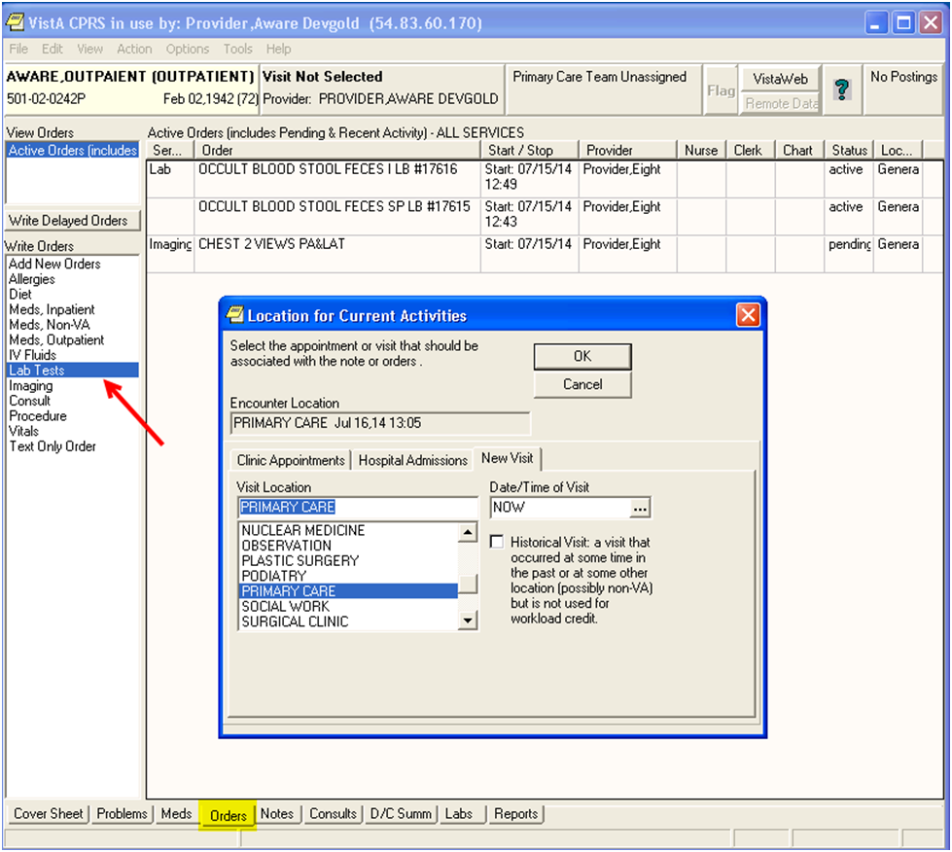

Figure 1 - Selecting Location for Current Activities

1. Select the appropriate Lab Order you wish to test (OCCULT BLOOD or PSA, or other site specific Laboratory Test names associated with lab Alert Types defined and made “Active” in the Knowledge Base Editor). Then click the Accept Order button. See Figure 2 - Order a Lab Test

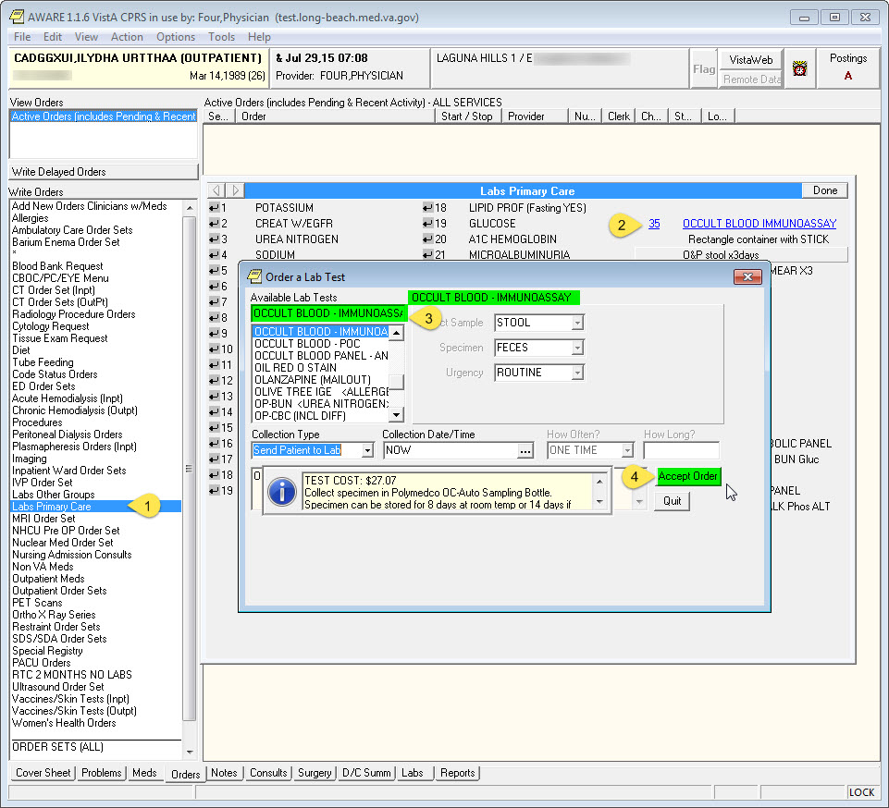

Figure 2 - Order a Lab Test

1. Next click the Quit button. See Figure 3 - Click the Quit Button

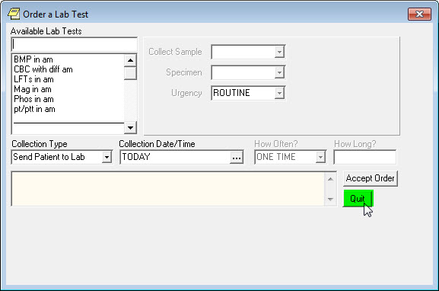

Figure 3 - Click the Quit Button

1. Next select “File”, “Review/Sign Changes”. Enter the Electronic Signature Code and click the Sign button. The Orders Status will change to “pending”. See Figure 4 - Review/Sign Changes

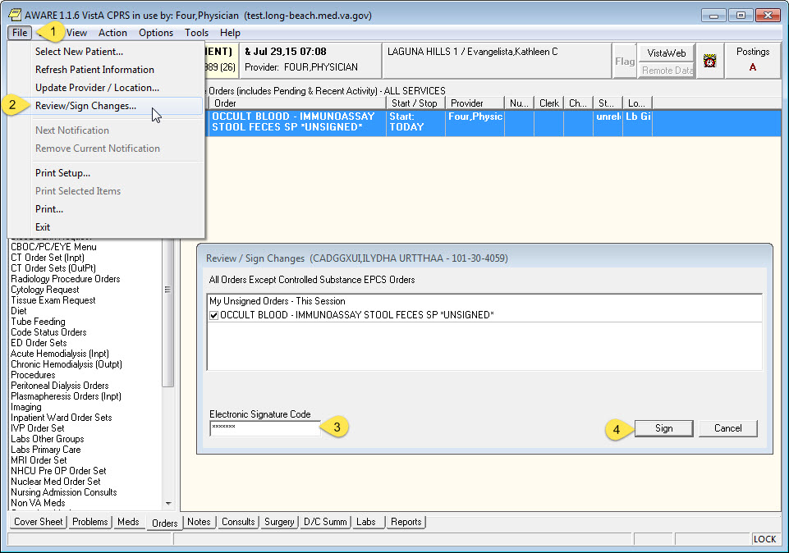

Figure 4 - Review/Sign Changes

1. Note Lab Test number. The Lab number (LB #) is needed to process the lab test. See Figure 5 - Lab Test Number

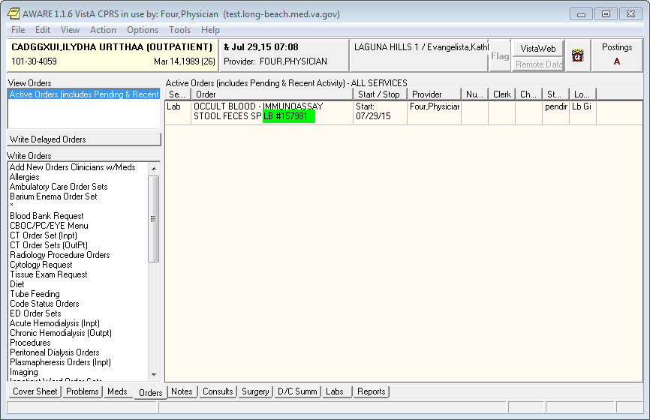

Figure 5 - Lab Test Number

1. The next step is to process the Lab Order for the selected patient. AWARE CPRS can be minimized if needed.
2. Open a Reflections session and Log on to VistA as a Lab Technician to process the Lab Tests. See Figure 6 below.

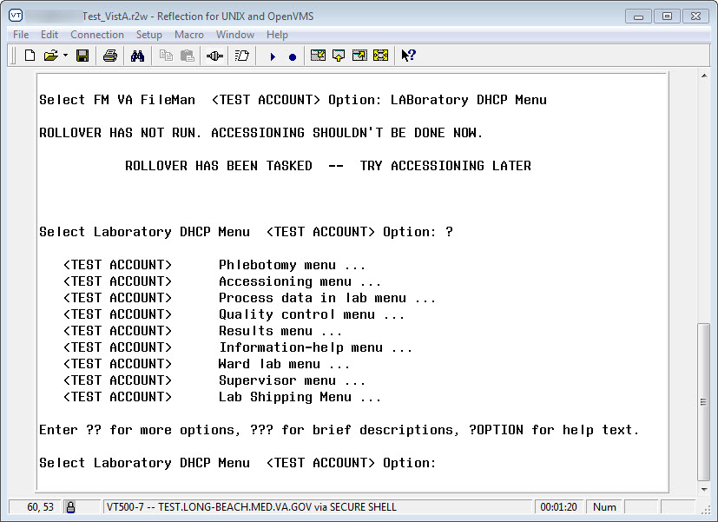

Figure 6 – Reflections VistA Logon

1. Select Laboratory DHCP Menu [LRMENU]. See Figure 6 – Reflections VistA Logon above.
2. Select Process Data In Lab Menu

Select Laboratory DHCP Menu <TEST ACCOUNT> Option: ??

<TEST ACCOUNT> Phlebotomy menu ... [LR GET]

<TEST ACCOUNT> Accessioning menu ... [LR IN]

**<TEST ACCOUNT> Process data in lab menu ... [LR DO!]**

<TEST ACCOUNT> Quality control menu ... [LRQCM]

<TEST ACCOUNT> Results menu ... [LR OUT]

<TEST ACCOUNT> Information-help menu ... [LRHELP]

<TEST ACCOUNT> Ward lab menu ... [LRWARDM]

**> Locked with LRLAB

<TEST ACCOUNT> Supervisor menu ... [LRSUPERVISOR]

**> Locked with LRSUPER

<TEST ACCOUNT> Lab Shipping Menu ... [LA7S MAIN MENU]

Select Laboratory DHCP Menu <TEST ACCOUNT> Option: **Process data in lab menu**

1. Select Accession order then immediately enter data

Select Process data in lab menu <TEST ACCOUNT> Option: ?

<TEST ACCOUNT> Enter/verify data (auto instrument)

<TEST ACCOUNT> Enter/verify data (Load list)

<TEST ACCOUNT> Enter/verify/modify data (manual)

<TEST ACCOUNT> Enter/verify data (Work list)

<TEST ACCOUNT> Misc. Processing Menu ...

**<TEST ACCOUNT> Accession order then immediately enter data**

**[LR ACC THEN DATA]**

<TEST ACCOUNT> Batch data entry (chem, hem, tox, etc.)

**> Out of order: OUT OF ORDER PER PATIENT SAFETY

<TEST ACCOUNT> Build a load/work list

<TEST ACCOUNT> Bypass normal data entry

<TEST ACCOUNT> Download a load list to an Instrument.

<TEST ACCOUNT> Fast Bypass Data Entry/Verify

<TEST ACCOUNT> Lookup accession

<TEST ACCOUNT> Order/test status

<TEST ACCOUNT> Print a load/work list

<TEST ACCOUNT> Std/QC/Reps Manual Workload count

<TEST ACCOUNT> Unload Load/Work List

Select Process data in lab menu <TEST ACCOUNT> Option: **Accession order then immediately enter data**

1. Enter the Sites Preforming Laboratory, Lab Order Number and all the required lab data to complete the Lab Test.

Select Performing Laboratory: LONG BEACH VAMC// MC&NH CA VAMC 600

Select Order number: **157981**

CADGGXUI,ILYDHA URTTHAA xxxzzyyyy Requesting location: &

Date/Time Ordered: 07/29/2015 07:34 By: FOUR,PHYSICIAN

-Lab Order # 157981 Provider: FOUR,PHYSICIAN

STOOL FECES

OCCULT BLOOD - IMMUNOASSAY

ROUTINE Requested (SEND PATIENT) for: 07/29/2015

Is this the correct order? Yes// **YES**

Collection Date@Time: //**NOW** (JUL 29, 2015@08:30:36)

Print labels on: LABLABEL// NULL NULL DEVICE

Do you wish to test the label printer: NO//

ACCESSION: FOBTM 0729 1 <3852100001>

OCCULT BLOOD - IMMUNOASSAY STOOL FECES

Work Load Area: FOBT

Sample: STOOL

Specimen: FECES

1 OCCULT BLOOD - IMMUNOASSAY

CADGGXUI,ILYDHA URTTHAA SSN: xxxzzyyyy LOC: &

Pat Info: Sex: MALE Age: 26yr as of Jul 29, 2015

Provider: FOUR,PHYSICIAN Voice pager: 714-506-2230

Phone: Digital pager: 714-506-2230

ACCESSION: FOBTM 0729 1 [3852100001]

7/29 08:30d

***Enter* “POS” *in the test value field, which will is a Critical Value for Occult Blood laboratory test. This will trigger an AWARE Critical Labs Alert.***

FOBT1 IMMUNOASSAY //**POS** POSITIVE CRITICAL HIGH!!

FOBT1 IMMUNOASSAY QUANT //**3**

Select COMMENT: **<RET**

CADGGXUI,ILYDHA URTTHAA SSN: xxxzzyyyy LOC: &

Pat Info: Sex: MALE Age: 26yr as of Jul 29, 2015

Provider: FOUR,PHYSICIAN Voice pager: 714-506-2230

Phone: Digital pager: 714-506-2230

ACCESSION: FOBTM 0729 1 [3852100001]

7/29 08:30d

FOBT1 IMMUNOASSAY POSITIVE H* CRITICAL HIGH!!

FOBT1 IMMUNOASSAY QUANT 3 ng/mL

SELECT ('E' to Edit, 'C' for Comments, 'W' Workload):

Approve for release by entering your initials: **JSG**

1. This completes all the steps required to be done by the Laboratory Technician.
2. Next switch back to AWARE CPRS. Select “File”, “Refresh Patient Information”. See Figure 7 – Refresh Patient Lab Test Data below.

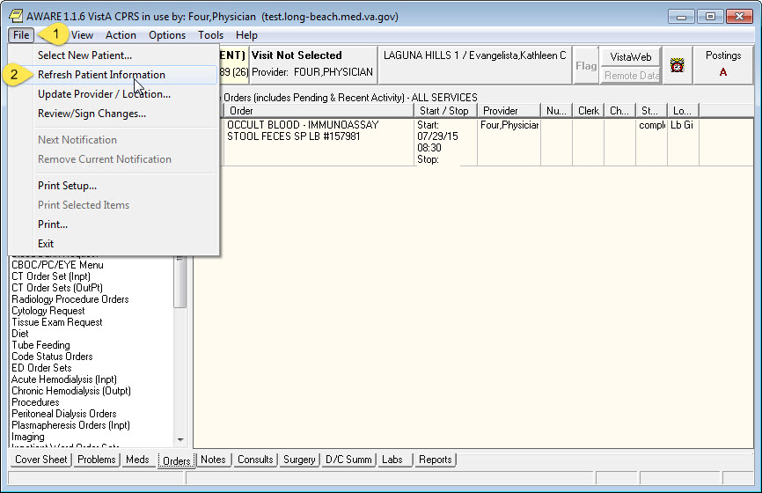

Figure 7 – Refresh Patient Lab Test Data

1. Click the “Labs” tab to see the Lab test results. See Figure 8 – Patients Lab Test Data below.

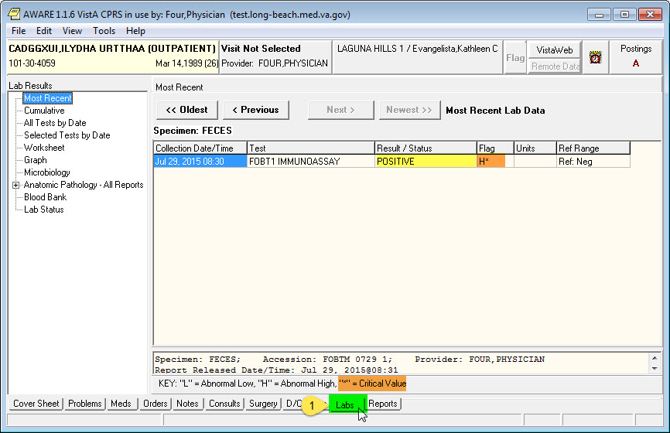

Figure 8 – Patients Lab Test Data

1. When the Provider attempts to close the patient chart by selecting File, Select New Patient…, the AWARE Prompt appears. See Figure 9 - AWARE Prompt below.

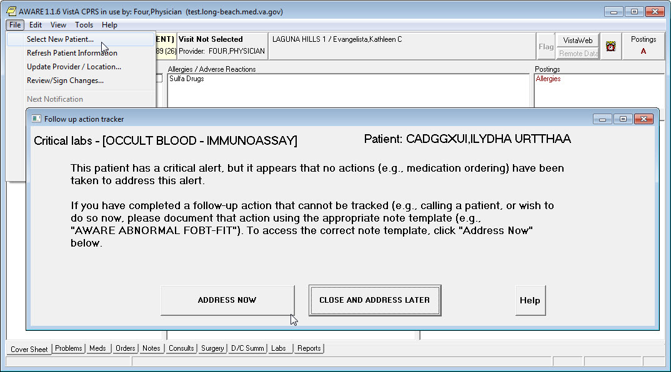

Figure 9 - AWARE Prompt

The steps above can be repeated for any of the defined and “Active” Lab Tests with associated Critical Lab Alert types in the Knowledge Base Editor.

See also Section 6 Processing AWARE Prompts/Pop-Ups for Follow-Up processing instructions.

# Creating AWARE Alerts for Abnormal Imaging Alert Categories

Testing of AWARE Abnormal Imaging Category of Alerts first requires a CPRS user (Usually a Clinician/Provider) to create Imaging/Radiology Orders associated with defined AWARE Alert Types for a selected patient. Then a Radiology Technologist is required to register the patient and complete the exam, and then an Interpreting Staff Radiologist is required to verify the films, and enter other data including any resulting diagnostic code. After the order is completed/verified and the case is completed, the provider or another Alert recipient for that kind of Alert category will be prompted for making follow-up actions towards the Abnormal Image result at time of patient closeout.

1. Log in to CPRS as a Provider and select a test patient. Then click the Orders tab and click Imaging or Radiology Orders from the left side. Select the Imaging Type, Imaging Procedure, Reason for Study, Date Desired, Submit To, and then click the Accept Order button. See Figure 10 below. Note: Each site may look different.

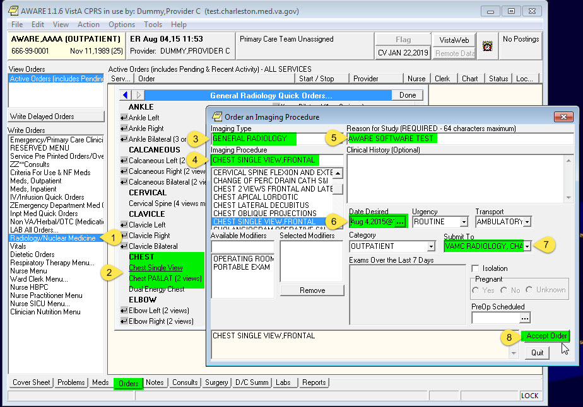

Figure 10 – Enter Imaging Order

1. If Order Checking is displayed, click Accept Order Button. See Figure 11 below

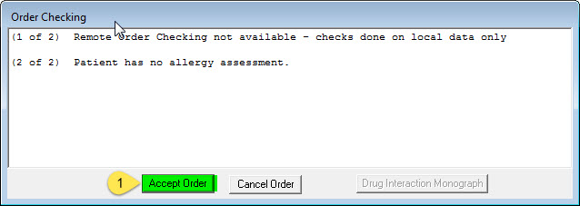

Figure 11 –Order Checking

1. Next right click the Order and select Sign. See Figure 12 below.

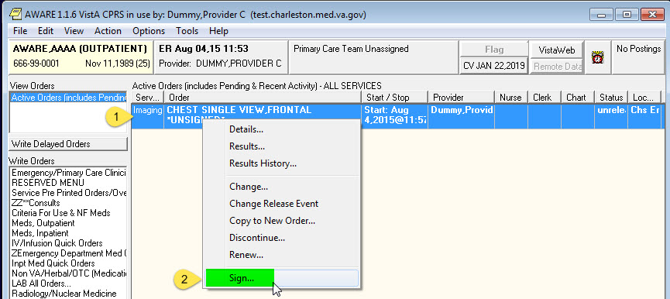

Figure 12 – Sign Imaging Order

1. If Order Check is displayed, Enter Reason for Overriding Order Checks and click Accept Order(s) button. See Figure 13 below.

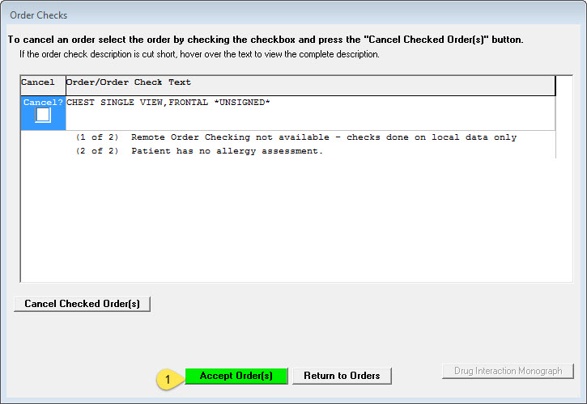

Figure 13 – Order Check

1. Enter your Electronic Signature Code and click Sign button. See Figure 14 below.

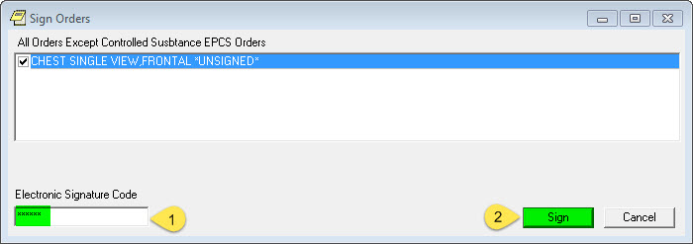

Figure 14 – E-Sign Order

1. The next step is to process the Imaging Order for the selected patient. AWARE CPRS can be minimized if needed.
2. Open a Reflections session and Log on to VistA as a Radiology Technologist or Staff member to process the Imaging request. See Figure 15 below.

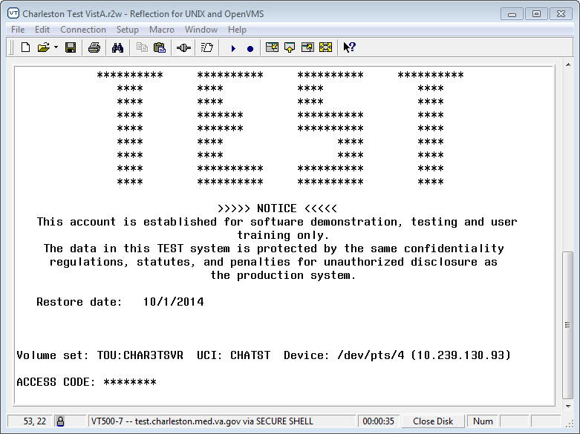

Figure 15 – Reflections VistA Logon

1. Select Exam Entry/Edit Menu [RA EXAMEDIT]. See below.

<TEST ACCOUNT> **Exam Entry/Edit Menu ...[RA EXAMEDIT]**

<TEST ACCOUNT> Films Reporting Menu ...[RA RPT]

<TEST ACCOUNT> Management Reports Menu ...

<TEST ACCOUNT> Outside Films Registry Menu ...

<TEST ACCOUNT> Patient Profile Menu ...

<TEST ACCOUNT> Radiology/Nuclear Med Order Entry Menu ...

<TEST ACCOUNT> Supervisor Menu ...

<TEST ACCOUNT> Switch Locations

<TEST ACCOUNT> Update Patient Record

<TEST ACCOUNT> User Utility Menu ...

Select Rad/Nuc Med Total System Menu <TEST ACCOUNT> Option: **Exam Entry/Edit Menu**

1. Select Register Patient for Exams [RA REG]. Then enter the Patient Name.

<TEST ACCOUNT> Add Exams to Last Visit

<TEST ACCOUNT> Cancel an Exam

<TEST ACCOUNT> Case No. Exam Edit [RA EDITCN]

<TEST ACCOUNT> Diagnostic Code and Interpreter Edit by Case No.

<TEST ACCOUNT> Edit Exam by Patient [RA EDITPT]

<TEST ACCOUNT> Enter Last Past Visit Before VISTA

<TEST ACCOUNT> Exam Status Display

<TEST ACCOUNT> Indicate No Purging of an Exam/report

<TEST ACCOUNT> **Register Patient for Exams [RA REG]**

<TEST ACCOUNT> Switch Locations

<TEST ACCOUNT> View Exam by Case No.

Select Exam Entry/Edit Menu <TEST ACCOUNT> Option: **Register Patient for Exams**

Select Patient: **AWARE,AAAA** 11-11-89 xxxzzyyyy NO NSC VETERAN

Combat Vet Status: ELIGIBLE End Date: 01/22/2019

*** Patient Requires a Means Test ***

Primary Means Test Required from AUG 4,2015

MEANS TEST REQUIRED

Are you adding 'AWARE,AAAA' as a new RAD/NUC MED PATIENT (the 123921ST)? No//**Y (Yes)**

*********** Patient Demographics ***********

Name : AWARE,AAAA

Pt ID : xxxzzyyyy

Date of Birth: NOV 11,1989 (25)

Veteran : Yes Eligibility : NSC

Sex : MALE

Other Allergies:

'V' denotes verified allergy 'N' denotes non-verified allergy

Case # Last 5 Procedures/New Orders Exam Dt Exam Status Imaging Loc.

---------------- ---------------------------- -------- ----------- ---------

CHEST SINGLE VIEW,FRONTAL Ord 8/4/15 VAMC RADI

No registered exams filed for this patient.

Imaging Exam Date/Time:

1. Enter Now for the Exam Date/Time. Then select Request(s) 1

Imaging Exam Date/Time: **NOW// N (AUG 04, 2015@12:37)**

**** Requested Exams for AWARE,AAAA **** 1 Requests

St Urgency Procedure / (Img. Loc.) Desired Requester Req'g Loc

-- ------- ------------------------- ---------- ----------- ---------

**1 p ROUTINE CHEST SINGLE VIEW,FRONTAL 08/04/2015 DUMMY,PROVI CHS EMERGEN** (VAMC RADIOLOGY, CHARS)

(Use Pn to replace request 'n' with a Printset procedure.)

Select Request(s) **1-1** or '^' to Exit: Exit**// 1**

Procedure: CHEST SINGLE VIEW,FRONTAL

...will now register AWARE,AAAA with the next case number(AUG 04, 2015@12:37)

Case Number: 4

----------------

PROCEDURE: CHEST SINGLE VIEW,FRONTAL// **<RET** (RAD Detailed) CPT:71010

Select PROCEDURE MODIFIERS: **<RET**

CATEGORY OF EXAM: OUTPATIENT// **OUTPATIENT**

PRINCIPAL CLINIC: CHS EMERGENCY DEPT DAY// **<RET**

TECHNOLOGIST COMMENT: **AWARE TESTING**

...all needed flash cards and exam labels queued to print on NULL DEVICE.

Task #: 17755845

Select Patient: **<RET**

1. Select Case No. Exam Edit. Then enter the Case No.

<TEST ACCOUNT> Add Exams to Last Visit

<TEST ACCOUNT> Cancel an Exam

<TEST ACCOUNT> **Case No. Exam Edit [RA EDITCN]**

<TEST ACCOUNT> Diagnostic Code and Interpreter Edit by Case No.

<TEST ACCOUNT> Edit Exam by Patient

<TEST ACCOUNT> Enter Last Past Visit Before VISTA

<TEST ACCOUNT> Exam Status Display

<TEST ACCOUNT> Indicate No Purging of an Exam/report

<TEST ACCOUNT> Register Patient for Exams

<TEST ACCOUNT> Switch Locations

<TEST ACCOUNT> View Exam by Case No.

Select Exam Entry/Edit Menu <TEST ACCOUNT> Option: **Case No. Exam Edit**

Enter Case Number: **534-080415-4**

Case No.: 4 Procedure: CHEST SINGLE VIEW,FRONTAL Name: AWARE,AAAA

(RAD Detailed) CPT:71010

PROCEDURE: CHEST SINGLE VIEW,FRONTAL//

CONTRAST MEDIA USED: NO// **NO** **<RET**

Select PROCEDURE MODIFIERS: **<RET**

Select CPT MODIFIERS: **<RET**

CATEGORY OF EXAM: OUTPATIENT// **<RET**

PRINCIPAL CLINIC: CHS EMERGENCY DEPT DAY// **<RET**

REQUESTING PHYSICIAN: DUMMY,PROVIDER C// **<RET**

Select TECHNOLOGIST: **BACHAR,CHERYL R CRB 114 RAD SPECIALTYR**

Select TECHNOLOGIST: **<RET**

TECHNOLOGIST COMMENT: AWARE TESTING// **<RET**

COMPLICATION: NO COMPLICATION// **<RET**

PRIMARY CAMERA/EQUIP/RM: **2 GENERAL RADIOGRAPHIC**

Select FILM SIZE: **14 X 14 U-V L**

AMOUNT(#films or cine ft): **1**

REPEAT REASON (LOCAL): **<RET**

Select FILM SIZE: **<RET**

...will now designate exam status as 'EXAMINED'

...for case no. 534-080415-4

...exam status successfully updated.

Enter Case Number: **<RET**

Select Exam Entry/Edit Menu <TEST ACCOUNT> Option: **<RET**

1. Select Films Reporting Menu. Then select Report Entry/Edit.

Select Rad/Nuc Med Total System Menu <TEST ACCOUNT> Option: **Films Reporting Menu**

Select Films Reporting Menu <TEST ACCOUNT> Option:

<TEST ACCOUNT> Batch Reports Menu ...

<TEST ACCOUNT> Display a Rad/Nuc Med Report

<TEST ACCOUNT> Distribution Queue Menu ...

<TEST ACCOUNT> Draft Report (Reprint)

<TEST ACCOUNT> On-line Verifying of Reports [RA RPTONLINEVERIFY]

<TEST ACCOUNT> Outside Report Entry/Edit

<TEST ACCOUNT> **Report Entry/Edit [RARPTENTRY]**

<TEST ACCOUNT> Resident On-Line Pre-Verification

<TEST ACCOUNT> Select Report to Print by Patient

<TEST ACCOUNT> Switch Locations

<TEST ACCOUNT> Verify Report Only

Select Films Reporting Menu <TEST ACCOUNT> Option: **Report Entry/Edit**

Note: To enter receipt of OUTSIDE INTERPRETED REPORTS,

please use the 'Outside Report/Entry Edit' option.

Select Rad/Nuc Med Division: All// **CHARLESTON VAMC SC VAMC 534**

Another one (Select/De-Select): **<RET**

Select Imaging Type: All// **GENERAL RADIOLOGY**

Enter your Current Signature Code: **SIGNATURE VERIFIED**

Do you want to batch print reports? Yes// **N ...no batch selected**

Enter Case Number: **534-080415-4**

-----------------------------------------------------------------------------

Name : AWARE,AAAA Pt ID : xxxzzyyyy

Case No. : 534-080415-4 Exm. St : EXAMINED

Procedure: CHEST SINGLE VIEW,FRONTAL

Tech.Comment: AWARE TESTING

Exam Date: AUG 4,2015 12:37 Technologist: BACHAR,CHERYL R

Req Phys : DUMMY,PROVIDER C

-----------------------------------------------------------------------------

...report not entered for this exam...

...will now initialize report entry...

Select Report to Copy: **<RET**

-----------------------------------------------------------------------------

PRIMARY INTERPRETING RESIDENT: **WEBSTER,SHARON A SAW ITD OI&T(VISTA**

Select SECONDARY INTERPRET'G RESIDENT:

PRIMARY INTERPRETING STAFF: **GREENACRE,JOHN S JSG AWARE BUSINESS ANALYST**

Select SECONDARY INTERPRETING STAFF: **<RET**

INTERPRETING IMAGING LOCATION: VAMC RADIOLOGY, CHARS**//(GENERAL RADIOLOGY-534)**

-----------------------------------------------------------------------------

...report not entered for this exam...

...will now initialize report entry...

Select Report to Copy: **<RET**

-----------------------------------------------------------------------------

PRIMARY INTERPRETING RESIDENT: NGUYEN,HUAN T HTN 05/114

Select SECONDARY INTERPRET'G RESIDENT: **<RET**

PRIMARY INTERPRETING STAFF: GREENACRE,JOHN S JSG VA

Select SECONDARY INTERPRETING STAFF: **<RET**

Select 'Standard' Report to Copy: 4 FEE BASIS SCANNED REPORTS

Are you sure you want the 'FEE BASIS SCANNED REPORTS' standard report? No// **Y**

Do you want to add another standard to this report? No// **<RET**

-----------------------------------------------------------------------------

REPORTED DATE: **Now (AUG 04, 2015)**

----------------------------------------------------------------------------

CLINICAL HISTORY: **<RET**

ADDITIONAL CLINICAL HISTORY:

No existing text

Edit? NO// **<RET**

---------------------------------------------------------------------------

REPORT TEXT:. . .

**************************************************************************

THIS STUDY AND REPORT WERE RENDERED BY A FEE BASIS CONTRACTOR.

VERIFICATION OF THIS REPORT IS ONLY ASSURING THAT THE INFORMATION ENTERED

IS THE SAME AS TRANSCRIBED ON THE ORIGINAL REPORT BY THE CONTRACTOR.

PLEASE SEE FEE BASED SCANNED DOCUMENT IN VISTA IMAGING DISPLAY.

Edit? NO// **<RET**

--------------------------------------------------------------------

IMPRESSION TEXT:

**************************************************************************

************************* NOTICE *************************

**************************************************************************

THIS STUDY AND REPORT WERE RENDERED BY A FEE BASIS CONTRACTOR.

VERIFICATION OF THIS REPORT IS ONLY ASSURING THAT THE INFORMATION ENTERED

IS THE SAME AS TRANSCRIBED ON THE ORIGINAL REPORT BY THE CONTRACTOR.

PLEASE SEE FEE BASED SCANNED DOCUMENT IN VISTA IMAGING DISPLAY.

Edit? NO// **YES**

==[ WRAP ]==[ INSERT ]========< IMPRESSION TEXT >=========[ <PF1>H=Help ]====

**************************************************************************

************************* NOTICE *************************

**************************************************************************

THIS STUDY AND REPORT WERE RENDERED BY A FEE BASIS CONTRACTOR.

VERIFICATION OF THIS REPORT IS ONLY ASSURING THAT THE INFORMATION ENTERED

IS THE SAME AS TRANSCRIBED ON THE ORIGINAL REPORT BY THE CONTRACTOR.

PLEASE SEE FEE BASED SCANNED DOCUMENT IN VISTA IMAGING DISPLAY.

**ABNORMAL IMAGE ATTENTION NEEDED**

<=======T=======T=======T=======T=======T=======T=======T=======T=======T>===

-----------------------------------------------------------------------------

Select one of the following:

**V VERIFIED**

PD PROBLEM DRAFT

D DRAFT

REPORT STATUS: D// **VERIFIED**

INTERPRETING IMAGING LOCATION: LB CT// (CT SCAN-600)

-----------------------------------------------------------------------------

Select 'Standard' Report to Copy: **<RET**

-----------------------------------------------------------------------------

REPORTED DATE: N (AUG 03, 2015)

-----------------------------------------------------------------------------

CLINICAL HISTORY:

ADDITIONAL CLINICAL HISTORY:

No existing text

Edit? NO//

-----------------------------------------------------------------------------

REPORT TEXT:

No existing text

Edit? NO//

-----------------------------------------------------------------------------

Select one of the following:

**V VERIFIED**

R RELEASED/NOT VERIFIED

PD PROBLEM DRAFT

D DRAFT

REPORT STATUS: D// **VERIFIED**

PRIMARY DIAGNOSTIC CODE: **4 ABNORMALITY, ATTN. NEEDED**

Select SECONDARY DIAGNOSTIC CODE: **<RET**

Status update queued!

Do you wish to print this report? No// **<RET**

Enter Case Number: **<RET**

1. This completes all the steps required to be done by the Radiology Staff.
2. Next switch back to AWARE CPRS.
3. When the Provider attempts to close the patient chart by selecting File, Select New Patient…, the AWARE Prompt appears. See Figure 16 below.

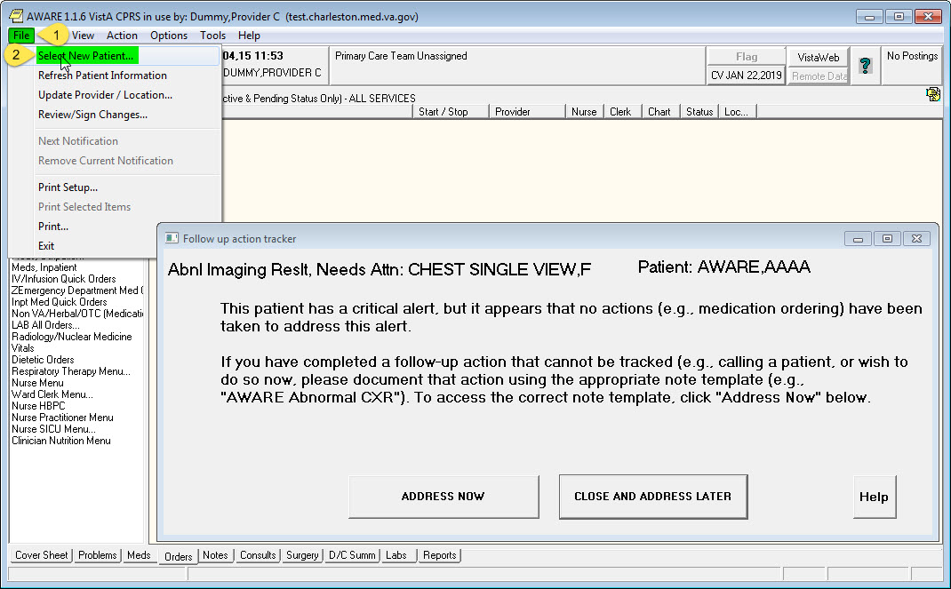

Figure 16 – Close Chart & AWARE Prompt

The steps above can be repeated for any of the defined and “Active” AWARE Alerts with associated Abnormal Imaging Alert Types in the Knowledge Base Editor.

See also Section 6 Processing AWARE Prompts/Pop-Ups below for Follow-Up processing instructions.

# Processing AWARE Prompts/Pop-Ups

After an AWARE Alert is triggered for a patient, the provider that ordered a lab order or imaging test/ procedure with a resulting abnormal value, or any other Alert recipient having this alert in their CPRS notification window will receive an AWARE CPRS Prompt/Pop-Up when closing out the affected patient’s Chart. **Note,** this will only occur if the provider is using the AWARE_CPRS executable.

Once the AWARE Prompt is displayed the provider has two options. First option is to do ADDRESS NOW to have an opportunity for performing follow-up actions via a subsequent Reminder dialog, and second options is to do a CLOSE AND ADDRESS LATER.

See Abnormal Image Alert example in Figure 17 below.

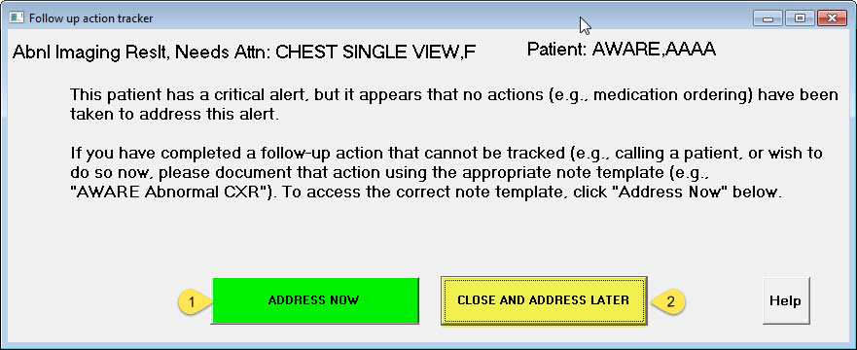

Figure 17 –AWARE Follow-Up Action Tracker Prompt

1. When the **ADDRESS NOW** button is clicked, AWARE CPRS opens the Notes Tab of AWARE CPRS and displays Progress Notes Properties. Selection of a Visit Location &Progress Note title is requested with AWARE CPRS re-direction for then clicking an OK Button. See Figure 18 below

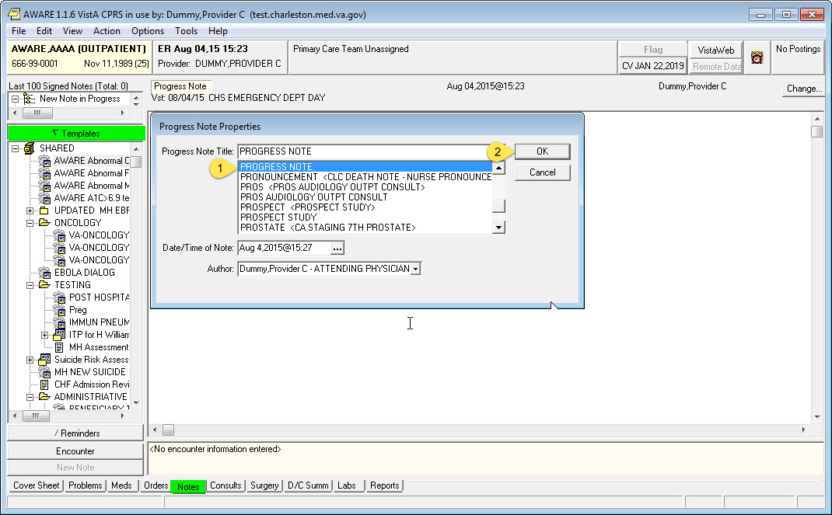

Figure 18 –AWARE Follow-Up Progress Note

The AWARE Reminder Dialog for the prompting Alert Type (Abnormal Imaging Alert Type in this example) is displayed. Provider can then enter the required Follow-Up actions needed for this Patient and then clicks the Finish button. **Note:** The provider may be required to complete and Sign Orders that were requested and complete the Encounter, and/or check “text” elements in the presented Reminder Dialog Template that represent “Other Follow-up” actions, and can enter a free text comment as a follow-up action as well. See Figure 19 below.

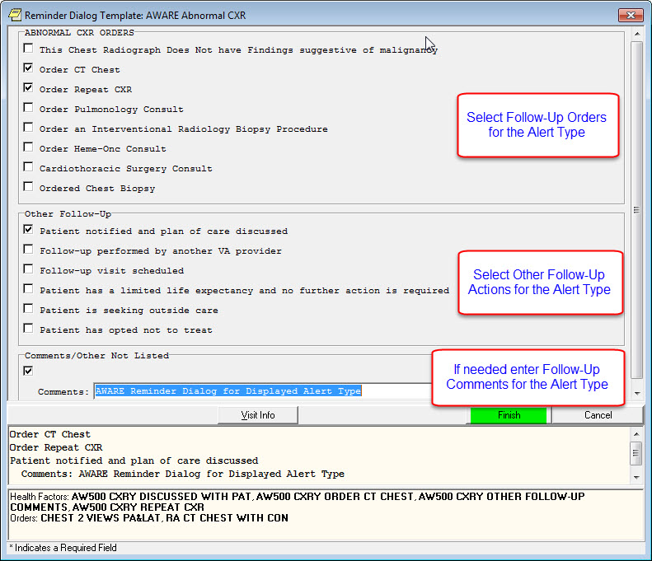

Figure 19 –AWARE Reminder Dialog

An Alert Tracker program fills in an Alert Provider field in an Alert Cache file with the provider entering the Follow-Up actions, and an Alert Status and Follow-Up Provider field is also filled with the provider entering the Follow-Up actions. This can be seen for the alert with the Alert Tracker program collecting other data for other fields as well such for Unacknowledged Alert Status, Renew and Delete Alert. These values as Patient alert details can be seen via a web-based n Alert Viewer program under the Status Tab. See Figure 20 below.

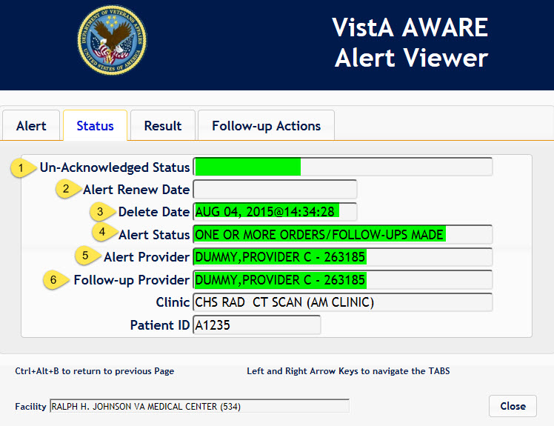

Figure 20 –Alert Viewer Status Tab

1. When the **CLOSE AND ADDRESS LATER** button is clicked AWARE CPRS opens the Patient Selection page without doing any follow-up actions on the closed out patient. See Figure 21 below.

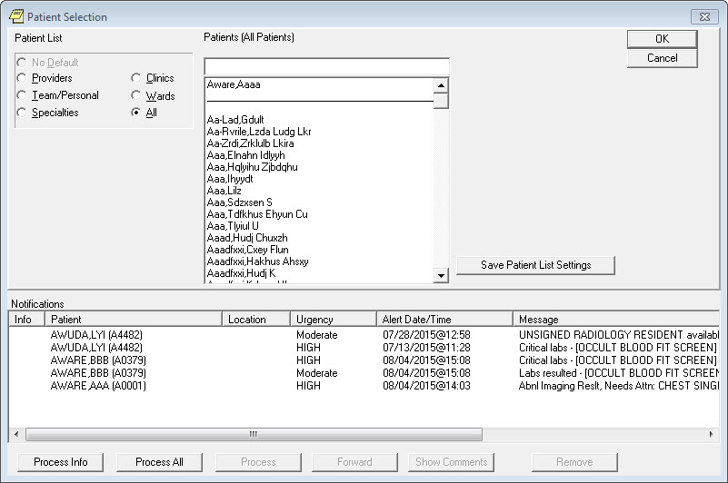

Figure 21 –AWARE CPRS Patient Selection

Additionally when the **CLOSE AND ADDRESS LATER** button is clicked, the AWARE Alert is closed and the Alert Renew Date is set. This can be seen in the Alert Viewer when drilling into the Patient Detail, under the Status Tab. See Figure 22 below.

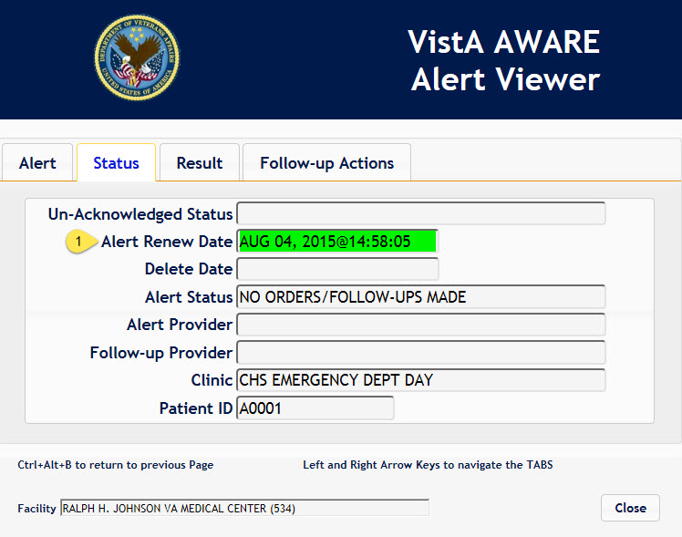

Figure 22 –Alert Viewer Patient Detail – Status Tab